PROJECT REPORT ON
“Movie Rating Analysis”
Submitted by:
Name: Elin Pattanayak
Roll No: 03BSC2364

Under the Guidance Of:
Mr. Bhabani Sankar Sahoo
Department of
Computer Science
June, 2025


DEPARTMENT OF COMPUTER SCIENCE
CREATIVE TECHNO COLLEGE
BALUAKATA, SARADHAPUR, ANGUL

STUDENT DECLARATION

I hereby declare that the project report entitled “Movie Rating Analysis” submitted in partial fulfillment of the requirement for the degree of BSc.CS(H)to Utkal University. This project is not submitted to any other university for the award of any other degree, diploma, fellowship or any other similar title of prizes.

Place: Name of Candidate
Date: Roll. No. –



CERTIFICATE

This is to certify that Ms. Elin Pattanayak a student of BSc.CS(H) fourth Semester bearing roll no: 03BSC2364 has successfully completed the bonafide project entitled “Project Title “. This project report is being accepted as the fulfillment of the requirement for the award degree of Bachelor of Computer Science at Creative techno College under Utkal University, Odisha.

Signature Signature
(Head of the Department) Internal Guide

ACKNOWLEDGEMENT
I would like to express my sincere gratitude to all those who have contributed to the completion of this project.

First and foremost, I extend my deepest appreciation to Mr. Bhabani Sankar Sahoo, my project supervisor, for their invaluable guidance, support, and encouragement throughout the duration of this project. Their expertise, constructive feedback, and unwavering commitment have been instrumental in shaping the direction and outcome of this work.

I am grateful to the faculty members of the Department of Computer Science for their continuous encouragement and for providing me with a conducive learning environment.

I would also like to thank my family for their unconditional love, patience, and unwavering belief in my abilities. Their support has been my source of strength and motivation throughout this journey.

Special thanks are due to my friends and classmates for their encouragement, insightful discussions, and moral support.

Last but not least, I am indebted to all the individuals who directly or indirectly contributed to this project through their valuable feedback, suggestions, and assistance.

Their contributions have played a significant role in the successful completion of this project.

Elin Pattanayak
03BSC2364
BSc.CS(H)

ABSTRACT

This project focuses on analysing a dataset of Bollywood movies to extract insights and identify trends within the Indian film industry. The primary objective is to explore, clean, and visualize the dataset to derive meaningful conclusions about key aspects such as movie popularity, production trends, and the presence of missing or duplicate data. Using Python-based libraries such as Pandas, Matplotlib, and Seaborn, the analysis begins with data exploration, including displaying the first and last rows, determining the dataset’s dimensions, and understanding its data types and memory requirements.

The methodology emphasizes data cleaning by identifying and addressing missing values and duplicates to ensure the reliability of subsequent analyses. Statistical summaries and visualizations are employed to uncover patterns, providing insights into production trends over time and correlations among attributes such as genres, ratings, and release years. By leveraging visualization techniques, the project highlights the distribution of ratings and identifies movies with significant audience appeal or critical acclaim.

In conclusion, the analysis offers a comprehensive overview of Bollywood movie data, facilitating better understanding and enabling data-driven decisions for stakeholders in the film industry. This study also underscores the importance of data preprocessing in achieving accurate and actionable results.

KEYWORDS

- Bollywood movies: Refers to films produced in the Indian Hindi-language film industry.
- Data analysis: The process of examining and interpreting data to extract useful insights.
- Python: A programming language used for data analysis and visualization in this project.
- Pandas: A Python library for data manipulation and analysis, used to preprocess and clean the dataset.
- Data visualization: The graphical representation of data to identify patterns and trends.
- Seaborn: A Python library for creating informative and attractive statistical graphics.
- Matplotlib: A Python library used for generating plots and charts.
- Data cleaning: The process of fixing or removing incorrect, corrupted, or incomplete data within the dataset.
- Missing values: Entries in the dataset where no data is recorded, requiring special handling.
- Duplicate data: Repeated entries in the dataset that need to be identified and removed for accuracy.
- Statistical analysis: Techniques used to summarize and interpret data characteristics and relationships.
- Movie trends: Patterns in movie production, popularity, or other metrics over time.
- Audience ratings: Evaluations provided by viewers, often indicating a movie's quality or appeal.
- Release years: The years in which movies were released, analyzed for temporal trends.
- Genres: Categories of movies, such as action, drama, or comedy, studied for distribution and popularity.
- Memory optimization: Efficient use of system resources during data analysis.
- Film industry insights: Observations and findings about the Bollywood industry derived from the dataset.
- Data-driven decisions: Decision-making processes guided by analysis and insights from data.
- Data preprocessing: Preparing raw data for analysis by cleaning, transforming, and organizing it.

CONTENTS

No. | Topics | Page
1. | Introduction | 1
2. | Objective | 2
3. | Problem Statement | 3
4. | S/W & H/W Requirements | 4
5. | Process | 5
6. | Code | 6
7. | Future Scope | 9
8. | Conclusion | 10
9. | Reference | 11

LIST OF FIGURES

Figure | Figure Name | Page No
Figure 1 | BarPlot | 8
Figure 2 | Histplot | 8

INTRODUCTION

- The provided Python code demonstrates fundamental data analysis and visualization techniques using the Pandas, Matplotlib, and Seaborn libraries. It starts by reading a CSV file named 'BollywoodMovieDetail.csv', which presumably contains information about Bollywood movies such as titles, genres, release years, ratings, and unique IDs. The code inspects the dataset’s structure using head(), tail(), and info() functions, and checks for missing or duplicated data. It calculates the percentage of missing values and handles them appropriately using dropna() and drop_duplicates().

- Several filtering techniques are employed, such as selecting specific movie titles, searching for titles containing a string, and extracting data from a particular year. The dataset is also reindexed by release year to facilitate easier year-wise filtering. Key descriptive statistics are obtained through describe(), and data with ratings less than or equal to 10 is extracted.

- The script also contains effective visualizations. A bar plot displays rating distributions by genre, a histogram shows overall rating distribution, and a pie chart illustrates how the highest-rated movies are distributed across different release years. The final filtered datasets are exported to new CSV files for further use. This structured approach is ideal for gaining insights from a Bollywood movie dataset.

1

OBJECTIVES

- Motivation: The motivation for this project stems from the growing importance of data analytics in the entertainment industry. With Bollywood being one of the largest film industries globally, understanding trends and insights from its data can assist filmmakers, producers, and marketers in making informed decisions.
- Desired Aims/Results/Objectives:
  - Analyze the dataset to identify patterns in movie production and popularity.
  - Address data inconsistencies by cleaning missing and duplicate values.
  - Generate visualizations that highlight correlations between various attributes such as genre, ratings, and release year.
  - Provide actionable insights to stakeholders within the film industry.
- Methodology Adopted:
  - The project utilizes Python libraries such as Pandas for data manipulation and Seaborn/Matplotlib for visualization.
  - Data cleaning processes include handling missing values and removing duplicates, ensuring reliable analysis.
  - Statistical summaries and visualizations uncover key trends, such as popular genres over the years or the relationship between ratings and release timing.
  - Unlike existing solutions, this project integrates data preprocessing techniques with trend analysis to offer a holistic perspective.
- Market or Industry Adaptability/Applications:
  - The insights derived from this project can guide film production strategies, marketing campaigns, and distribution planning.
  - It enables producers to understand audience preferences better and allocate resources effectively.
  - The analytical methods used are adaptable to other datasets in the entertainment sector, making it broadly applicable.
2

PROBLEM STATEMENT

- The problem statement of this project revolves around understanding and analyzing patterns in Bollywood movies using a structured dataset. With the growing number of films released every year, it becomes challenging to evaluate trends, audience preferences, and factors influencing a movie’s success. The dataset ‘BollywoodMovieDetail.csv’ contains information such as movie titles, genres, release years, ratings, and unique IDs. However, raw data alone is not insightful without proper analysis.

- The core problem lies in extracting meaningful information from this large dataset, identifying missing or duplicate values, and visualizing trends across different variables such as genre and release year. Additionally, there is a need to explore how ratings vary by movie type and year, and which factors contribute to higher-rated films. Addressing this problem helps filmmakers, critics, and researchers make data-driven decisions. The goal is to transform raw data into clear insights using data cleaning, filtering, and visualization techniques through Python-based tools.

3

S/W & H/W Requirements

Software Requirements:
- Python: A versatile programming language used for data manipulation and visualization.
- Pandas: Essential for data cleaning and preprocessing.
- Matplotlib: For creating static, interactive, and animated visualizations.
- Seaborn: To enhance Matplotlib's functionality for generating more attractive and informative plots.
- Jupyter Notebook: An interactive computing environment for developing and documenting the project.
Hardware Requirements:
- Minimum Specifications:
  - Processor: Intel Core i3 or equivalent
  - RAM: 4GB
  - Storage: 250GB HDD
- Recommended Specifications:
  - Processor: Intel Core i5 or higher
  - RAM: 8GB or more for handling larger datasets efficiently
  - Storage: 256GB SSD for faster read/write speeds
  - Graphics Card: Dedicated GPU (optional) for rendering complex visualizations

4

Process

Step 1: Data Acquisition
- Load the dataset into the Python environment using libraries like Pandas.
- Verify the integrity of the dataset, ensuring no structural corruption.
Step 2: Data Exploration
- Analyze the structure of the dataset, including its dimensions, data types, and memory usage.
- Identify key attributes such as genre, ratings, and release year for analysis.
Step 3: Data Cleaning
- Handle missing values by either imputing or removing them based on their relevance.
- Remove duplicate entries to ensure the uniqueness of each record.
- Standardize data formats for consistency across attributes.
Step 4: Statistical Analysis
- Compute descriptive statistics to understand the central tendencies and spread of key attributes.
- Analyze relationships between attributes, such as genre and ratings, using correlation measures.
Step 5: Data Visualization
- Generate plots to depict trends and patterns visually.
  - Histograms for rating distribution.
  - Line charts for temporal trends.
  - Bar charts to compare genres.
Step 6: Insight Extraction
- Interpret visualizations and statistical results to uncover key findings.
- Summarize insights related to production trends, audience preferences, and correlations.
Step 7: Documentation
- Record the methodology, findings, and visualizations in a comprehensive report.
- Highlight actionable recommendations for industry stakeholders.
5

Code

import pandas as pd
import matplotlib.pyplot as plt
import seaborn as sns

data = pd.read_csv('BollywoodMovieDetail.csv')

DISPLAY Top 10 Rows of the Dataset

first_ten_data=data.head(10)
first_ten_data.to_csv("first_ten_data_movies.csv", index =False)
first_ten_data
data.tail(10)
.shadatape
print("Number of rows", data.shape[0])
print("Number of Columns", data.shape[1])
data.info()
print("Any missimg value?", data.isnull().values.any())
data.isnull()
data.isnull().sum()
per_missing = data.isnull().sum() *100/len(data)
per_missing
data.dropna(axis=0)
dup_data = data.duplicated().any()
dup_data
data2=data.drop_duplicates()
data2
data.describe()
data[data['Rating']<=10]
specific_title =['Zid','Trip to Bhangarh']

data[data['Title'].isin(specific_title)]
6
data[data['Title'].str.contains('Ab')]
data2 = data.set_index('ReleaseYear')
data2
data2.filter(items = ['ID'], axis=1)
jawan_name_data=data2.filter(like ='2001', axis =0)
jawan_name_data.to_csv("1990_years.csv", index =False)
jawan_name_data
filtered_data = data[data['ID']<'tt0620612'].sort_values(by=['Rating'], ascending=False)
filtered_data
plt.figure(figsize=(10, 6))
sns.barplot(x='Genre', y='Rating', data=data.explode('Genre'))
plt.xticks(rotation=90)
plt.title("Rating Distribution by Genre")
plt.show()
plt.figure(figsize=(8, 5))
sns.histplot(data['Rating'], bins=10, kde=False)
plt.title("Distribution of Ratings")
plt.xlabel("Rating")
plt.ylabel("Count")
plt.show()
highest_rating = data['Rating'].max()
highest_rating_data = data[data['Rating'] == highest_rating]
# Count the occurrences of the highest rating by year
highest_rating_by_year = highest_rating_data['ReleaseYear'].value_counts()
# Plot: Pie chart
plt.figure(figsize=(8, 6))
plt.pie(highest_rating_by_year labels=highest_rating_by_year.index,
autopct='%1.1f%%' startangle=140)
plt.title(f"Distribution of Highest Rating ({highest_rating}) by Year")
plt.show()

filtered_data.to_csv("filtered_data.csv", index =False)
filtered_data
7

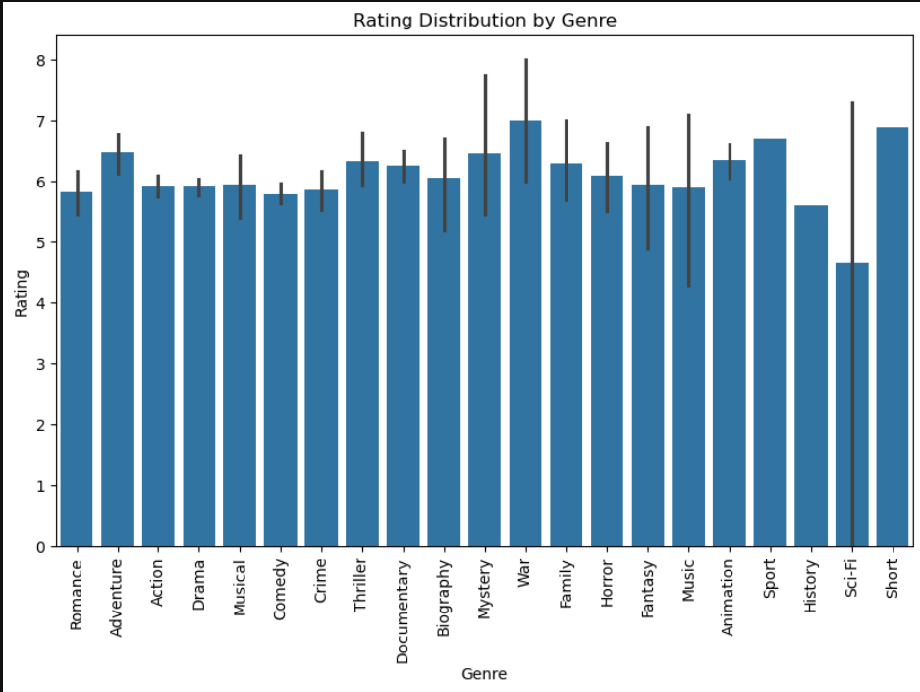
Fig 1

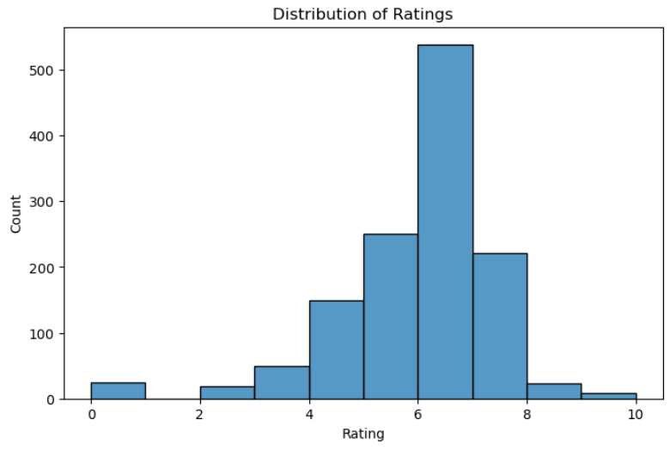

Fig 2

8

Future Scope

The Bollywood movie dataset analysis lays a foundation for extensive future explorations in the realm of entertainment analytics. Potential advancements include:
- Incorporating Additional Data Attributes: Expanding the dataset to include variables such as box office earnings, critical reviews, awards, and audience demographics for a more comprehensive analysis.
- Machine Learning Applications: Utilizing machine learning algorithms to predict the success of upcoming movies based on historical trends, including factors like casting, budget, and genre popularity.
- Real-Time Analytics: Implementing systems for real-time data collection and analysis, enabling immediate insights into audience reactions and market trends.
- Comparative Industry Analysis: Applying similar methodologies to other film industries globally, such as Hollywood, Tollywood, or European cinema, to identify cross-industry trends and dynamics.
- Sentiment Analysis: Analyzing social media data to gauge public sentiment towards movies before and after release, offering valuable inputs for marketing strategies.
- Customized Recommendation Systems: Developing advanced recommendation algorithms to enhance user experience on streaming platforms by identifying content aligned with viewer preferences.
- Sustainability Analytics: Exploring eco-friendly practices in film production by analyzing carbon footprints associated with various aspects of movie-making.

9

Conclusion

This analysis of Bollywood movies provides a comprehensive understanding of the industry's trends, challenges, and opportunities. By leveraging Python and its libraries, the project demonstrated the importance of data preprocessing, statistical analysis, and visualization in extracting actionable insights. Key findings include the identification of temporal production trends, audience preferences, and correlations between attributes such as genres and ratings.

The study underscores the potential of data analytics in enhancing decision-making processes for various stakeholders in the film industry. Producers can utilize these insights to align their strategies with market demands, while marketers can target audiences more effectively. Furthermore, the research highlights the importance of addressing data quality issues, such as missing values and duplicates, to ensure reliable and accurate analysis.

This project lays the groundwork for future explorations in entertainment analytics, offering a robust framework for analyzing movie data. By integrating advanced methodologies, it paves the way for predictive analytics, sentiment analysis, and real-time insights, ultimately contributing to the innovation and sustainability of the film industry.

10

REFERENCES

1.https://www.google.com
2.Youtube.com
3.https://openai.com
4.https://chatgpt.com

11

